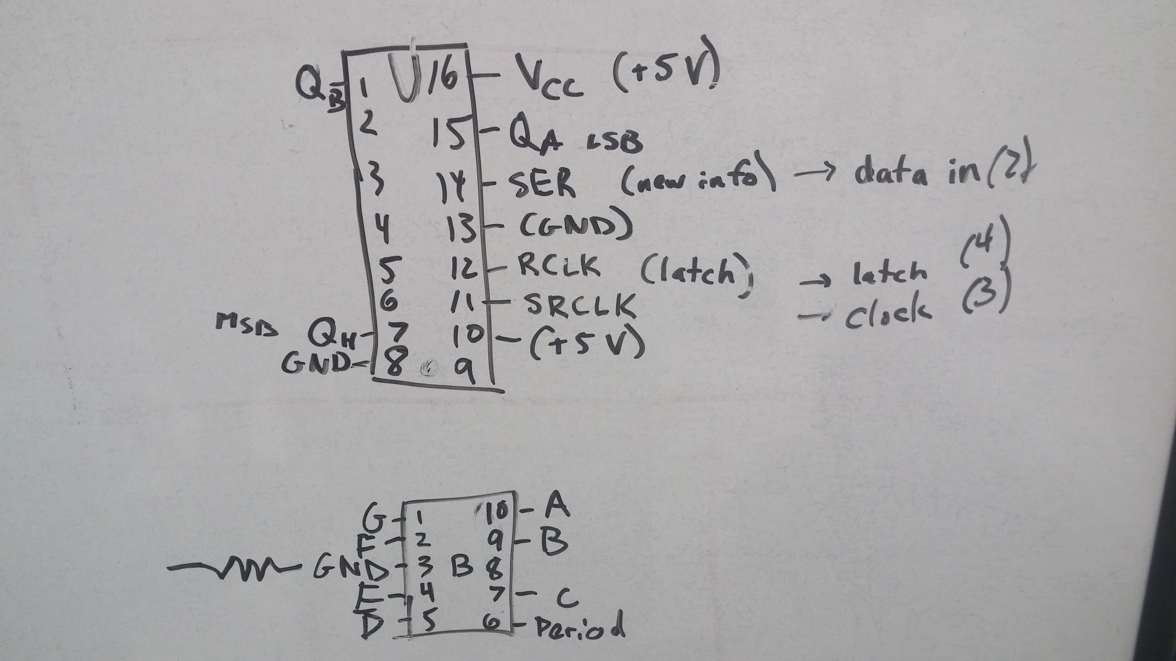**1. Team Members:** Andrew Jiang, David Xu, Nabib Ahmed, Sharanya Pulapura

**2. Project Information:**

**a. Title of Project:** eyeLearn

**b. Discussion:** This project intends to aid the visually impaired and promote awareness of visual impairment by creating a user-friendly device that expands access in Braille to early childhood learning materials. Essentially, this project acts as a supplemental device for Braille tutoring – seeing teachers will be able to see the LED text patterns to reference the text being used, and visually-impaired students can learn to read by touching the shifting Braille text represented by moving solenoids while listening to sound frequencies that will allow them to develop intuition about the letters. This idea originated from Nabib’s work in developing assistive technology for the visually impaired during high school.

**c. Goal:** To offer equal learning opportunities for visually impaired children by allowing them access to the same early childhood learning materials that other children have.

**3. Resources:** No outside resources will be used apart from the lab materials given by the ES50 professors.

**4. Schedule:**

7 Nov: All schematics finished, all products ordered

14 Nov: LED display portion finished, controlled by Arduino

21 Nov: Set up solenoids and integrate them with LEDs

28 Nov: Set up sound systems and create user interface (e.g. buttons to control speed)

4-9 Dec: Troubleshoot, test, debug, and improve aesthetic

**5. Block Diagram:**

The text signal (t) is an input in the system and is compared to a speed dial (s) whose settings are adjusted by the user. The modified signal is then sent to 4 outputs through four different systems. HL sends the signal to the 20 Braille character LED displays. HD sends the signal to the corresponding 20 fourteen-segment English letter displays that will appear below the LEDs. HS sends the signal to the set of 6 solenoids that will represent Braille characters in the text one at a time, at a speed specified by the user through the speed dial. The final system HF sends the same signal to to play sounds with frequencies that correspond with the Braille letters that are being output.

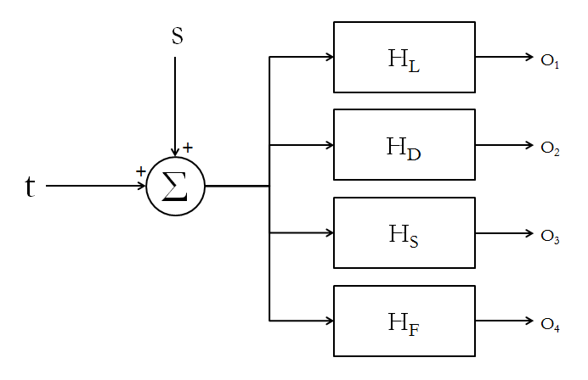

**6. Team Management:** There are four main components of our project. While we intend to work together on all parts, there must be a leader in every section of this project (i.e. to read data sheets, do work at home, etc.). The leaders are as follows:

Solenoids: Sharanya

LEDs/display: David

Sound: Nabib

Code: Andrew

**7. Additional Knowledge:** Solenoids and how they work, additional coding in Arduino, MATLAB

**8. Part List:**

Micro-solenoids (8) @$4.95:

<https://www.sparkfun.com/products/11015?gclid=CjwKEAjwh8exBRDyyqqH9pvf1ncSJAAu4OE3omrBbtZ3hzqtBaZGLtYxPod_pyo6hLW0i5cQ_llBjxoCirvw_wcB>

LEDs (20*8 = 160) - available in ES50 Lab

Fourteen-segment displays (20) - available in ES50 Lab (?)

Speakers - available in ES50 Lab

Shift Registers - available in ES50 Lab

Plastic/Acrylic/Wood/Metal Sheet (to be bought if not available in ES50 Lab)